**LECTURE 6**

**LOGICAL AGENTS, PREPOSITIONAL LOGIC AND FIRST ORDER LOGIC**

**LOGICAL AGENTS**

1. Goal Achievement: Logical agents are designed to achieve specific goals or objectives. They are motivated by the desire to reach these goals and to take actions that lead them closer to the desired state or outcome.
2. Rationality: Logical agents strive to make rational decisions based on the available information and their knowledge. They are motivated to choose actions that maximize their expected utility or achieve the best possible outcome, given the available resources and constraints.
3. Knowledge and Reasoning: Logical agents are motivated to utilize their knowledge and reasoning capabilities to make informed decisions. They aim to gather and process relevant information, apply logical rules, and draw conclusions that can guide their actions.
4. Adaptability: Logical agents are motivated to adapt to changes in their environment or circumstances. They seek to update their beliefs, revise their plans, and adjust their actions based on new information or changing conditions, in order to maintain effectiveness and efficiency.
5. Problem-Solving: Logical agents are motivated to solve problems and overcome challenges. They actively search for solutions, explore alternative options, and apply logical reasoning to find the most effective course of action.
6. Efficiency: Logical agents aim to achieve their goals in the most efficient manner possible. They are motivated to minimize resource usage, reduce unnecessary actions or computations, and optimize their decision-making process to achieve the desired outcome with minimal effort or cost.
7. Optimality: Logical agents strive for optimal solutions whenever possible. They are motivated to find the best possible outcome or action sequence that satisfies the given goals or constraints, based on their knowledge and available information.

The idea is that an agent can represent knowledge of its world, its goals and the current situation by sentences in logic and decide what to do by inferring that a certain action or course of action is appropriate to achieve its goals.

Agents with some representation of complex knowledge about the world/its environment and uses inference to deliver or derive new information from the knowledge combine with new inputs.

**KNOWLEDGE BASED AGENTS**

* Central component of a knowledge-based agent is a Knowledge-Base
* A set of sentences in a formal language
* Sentences are expressed using a knowledge representation language

Set of sentences in formal language representing facts about the world.

* Intelligent agents need knowledge about the world to choose good actions/decisions
* Knowledge – {sentences} in a knowledge representation in formal language
* Sentence is an assertion about the world
* Knowledge based agent is composed of knowledge base

1. Knowledge base – domain specific content
2. Inference mechanism – domain independent algorithm

The agent must be able to

* represent states, action etc..
* Incorporate new people
* Update internal representation of the world
* Deduce hidden properties of the world
* Reduce appropriate actions

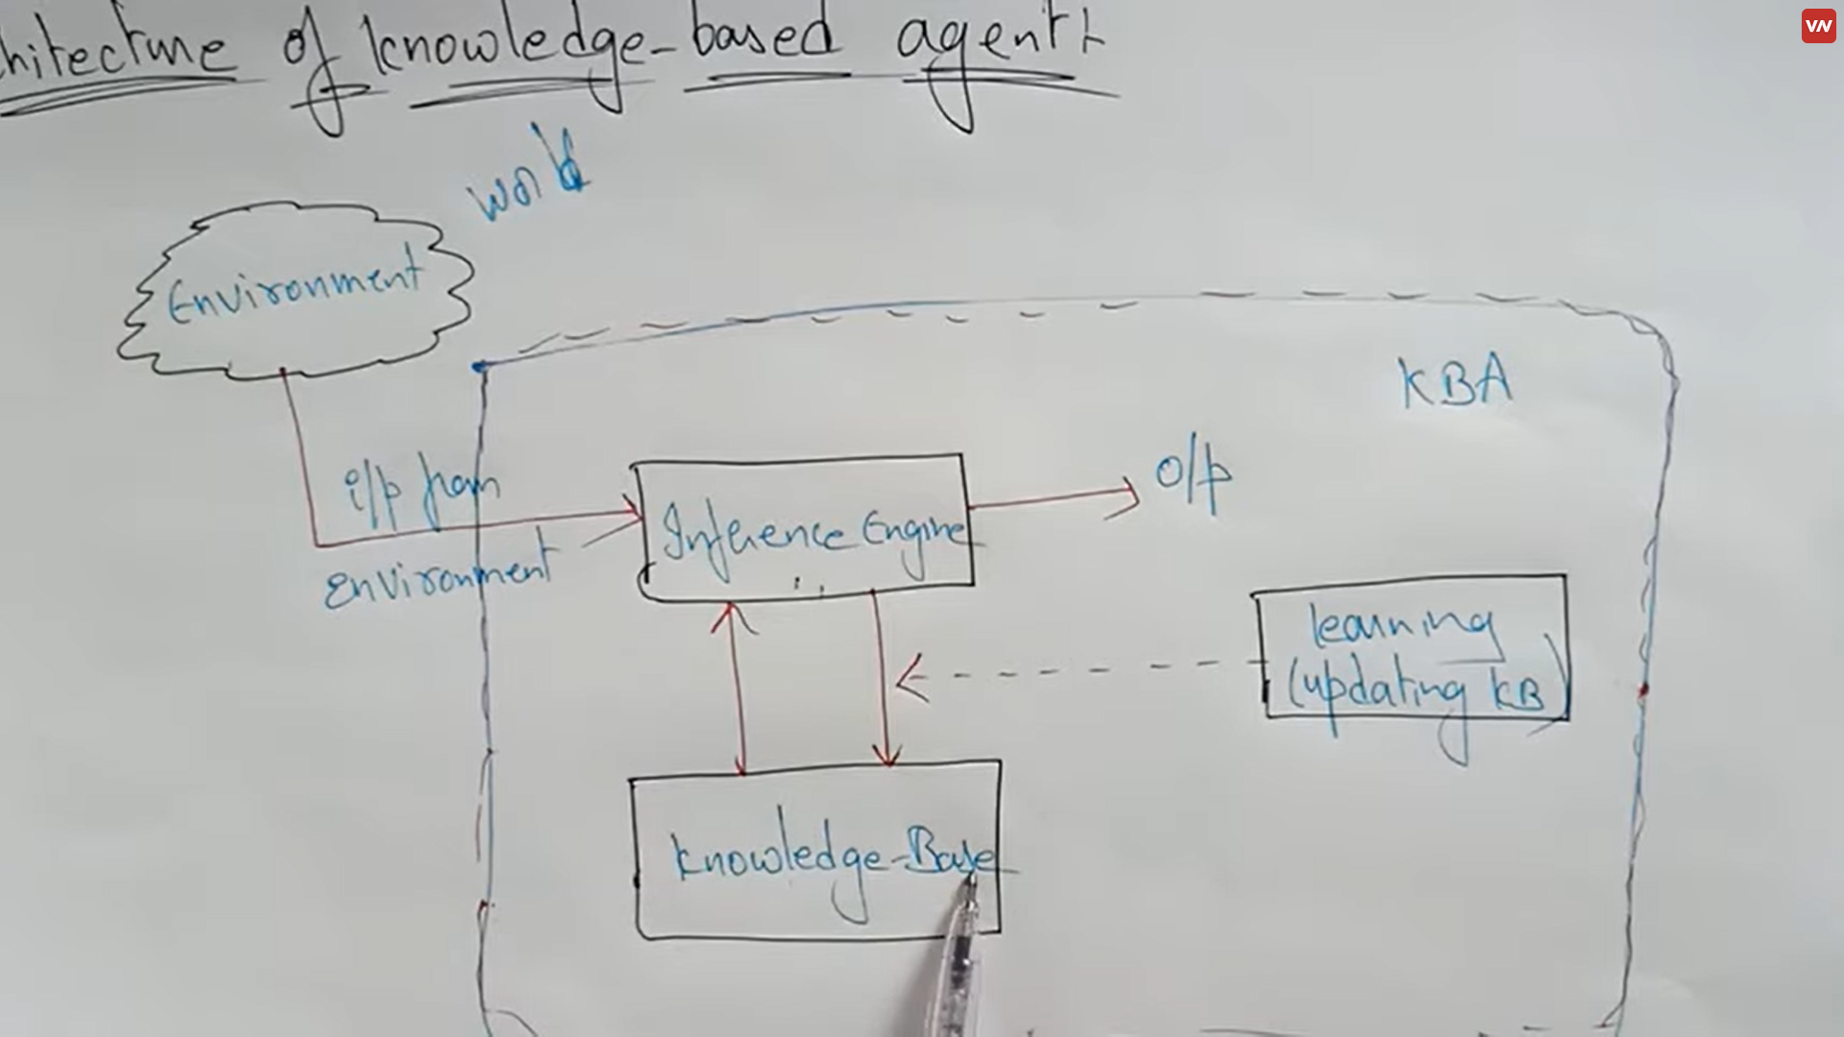

Environment known as world, so in the knowledge base it contains the logic, with the help of that knowledge base it takes the input from the environment, and generates an output. The updating knowledge base which is called learning whenever there is a requirements to add software or any updating you want to make to artificial intelligence, with the help of the knowledge base the inference engine is going to generate an output. It simply cannot generate the output without the help of the knowledge base and the updating knowledge base.

**DESIGNING KNOWLEDGE BASED AGENTS**

Declarative approach - : We can create a knowledgebased agent by initialising with an empty knowledge base and telling the agent all the sentences with which we want to start with and simply telling it what It needs to know.

Two generic functions:

1. TELL - add new sentences (facts) to the

knowledge base

• “Tell it what it needs to know”

1. ASK - query what is known from knowledge base

• “Ask what to do next”

Procedural - : Encode desired behavior directly as a program code that means minimizes the role of explicit representation and reasoning can result in much more efficient systems.

**EXAMPLE – WUMPUS WORLD PROBLEM**

The Wumpus world is a simple world example to illustrate the worth of a knowledge-based agent and to represent knowledge representation. It was inspired by a video game **Hunt the Wumpus** by Gregory Yob in 1973.

The Wumpus world is a cave which has 4/4 rooms connected with passageways. So there are total 16 rooms which are connected with each other. We have a knowledge-based agent who will go forward in this world. The cave has a room with a beast which is called Wumpus, who eats anyone who enters the room. The Wumpus can be shot by the agent, but the agent has a single arrow. In the Wumpus world, there are some Pits rooms which are bottomless, and if agent falls in Pits, then he will be stuck there forever. The exciting thing with this cave is that in one room there is a possibility of finding a heap of gold. So the agent goal is to find the gold and climb out the cave without fallen into Pits or eaten by Wumpus. The agent will get a reward if he comes out with gold, and he will get a penalty if eaten by Wumpus or falls in the pit.

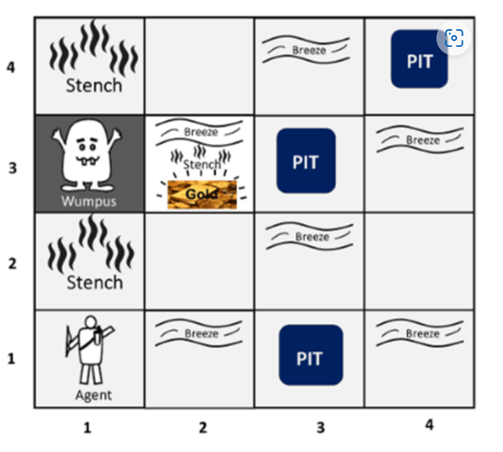

**PEAS description of Wumpus world:**

To explain the Wumpus world we have given PEAS description as below:

### Performance measure:

* +1000 reward points if the agent comes out of the cave with the gold.
* -1000 points penalty for being eaten by the Wumpus or falling into the pit.
* -1 for each action, and -10 for using an arrow.
* The game ends if either agent dies or came out of the cave.

Environment:

* A 4*4 grid of rooms.
* The agent initially in room square [1, 1], facing toward the right.
* Location of Wumpus and gold are chosen randomly except the first square [1,1].
* Each square of the cave can be a pit with probability 0.2 except the first square.

### Actuators:

* Left turn,
* Right turn
* Move forward
* Grab
* Release
* Shoot.

### Sensors:

* The agent will perceive the **stench** if he is in the room adjacent to the Wumpus. (Not diagonally).
* The agent will perceive **breeze** if he is in the room directly adjacent to the Pit.
* The agent will perceive the **glitter** in the room where the gold is present.
* The agent will perceive the **bump** if he walks into a wall.
* When the Wumpus is shot, it emits a horrible **scream** which can be perceived anywhere in the cave.
* These percepts can be represented as five element list, in which we will have different indicators for each sensor.
* Example if agent perceives stench, breeze, but no glitter, no bump, and no scream then it can be represented as:  
  **[Stench, Breeze, None, None, None]**.

## **The Wumpus world Properties:**

* **Partially observable:** The Wumpus world is partially observable because the agent can only perceive the close environment such as an adjacent room.
* **Deterministic:** It is deterministic, as the result and outcome of the world are already known.
* **Sequential:** The order is important, so it is sequential.
* **Static:** It is static as Wumpus and Pits are not moving.
* **Discrete:** The environment is discrete.
* **One agent:** The environment is a single agent as we have one agent only and Wumpus is not considered as an agent.

**LOGICAL REASONING**

In each case where the agent draws a conclusion from the available information, that conclusion is guaranteed to be correct if the available information is correct.

It is a language with some rules which deals with properties and has no ambiguity in representation, each sentence can be translated into logic using syntax and semantics.

Syntax – well formed sentence in the language

Semantic – defines the truth or meaning of sentence in the world.

Logical representation can be explained with the help of

* Propositional logic
* First order logic

**PROPOSITIONAL LOGIC**

* It is the simplest logic
* A proposition is a declarative statement that is either true or false
* Syntax of PL: defines the allowable sentences or propositions.
* Atomic Proposition: Single proposition symbol. Each symbol is a proposition. Notation: upper case letters and may contain subscripts
* Compound proposition: Constructed from atomic propositions using parentheses and logical connectives.

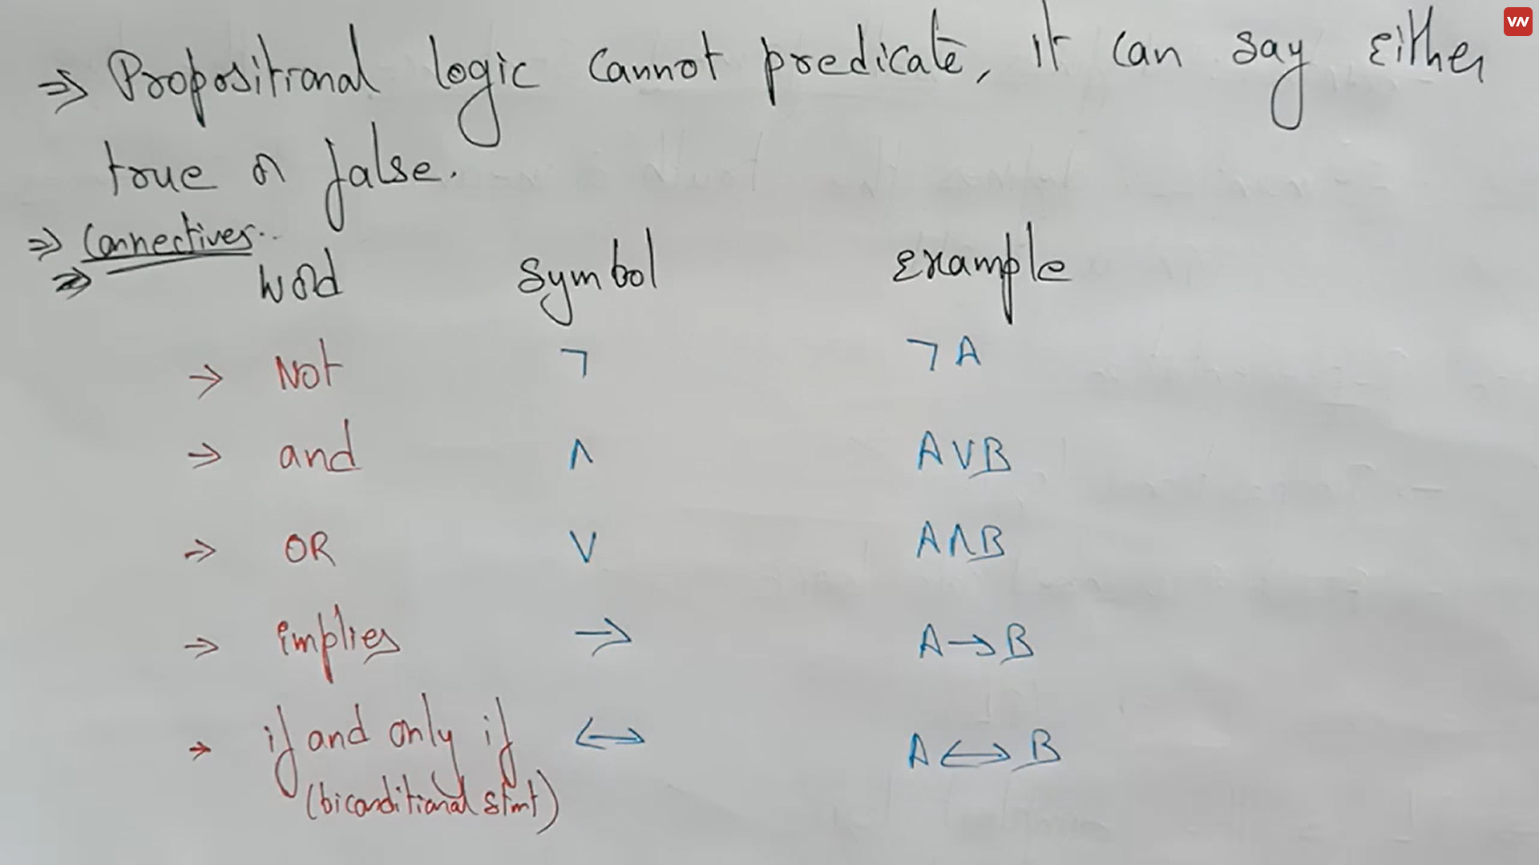

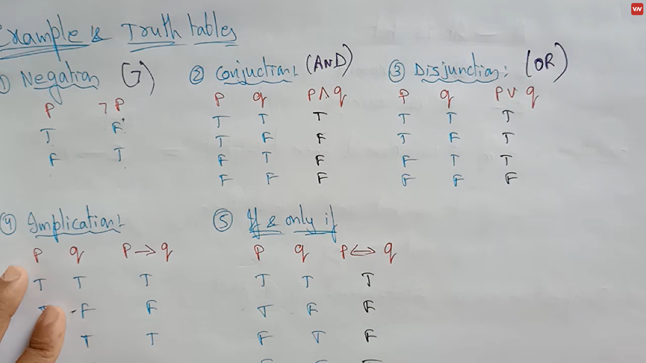

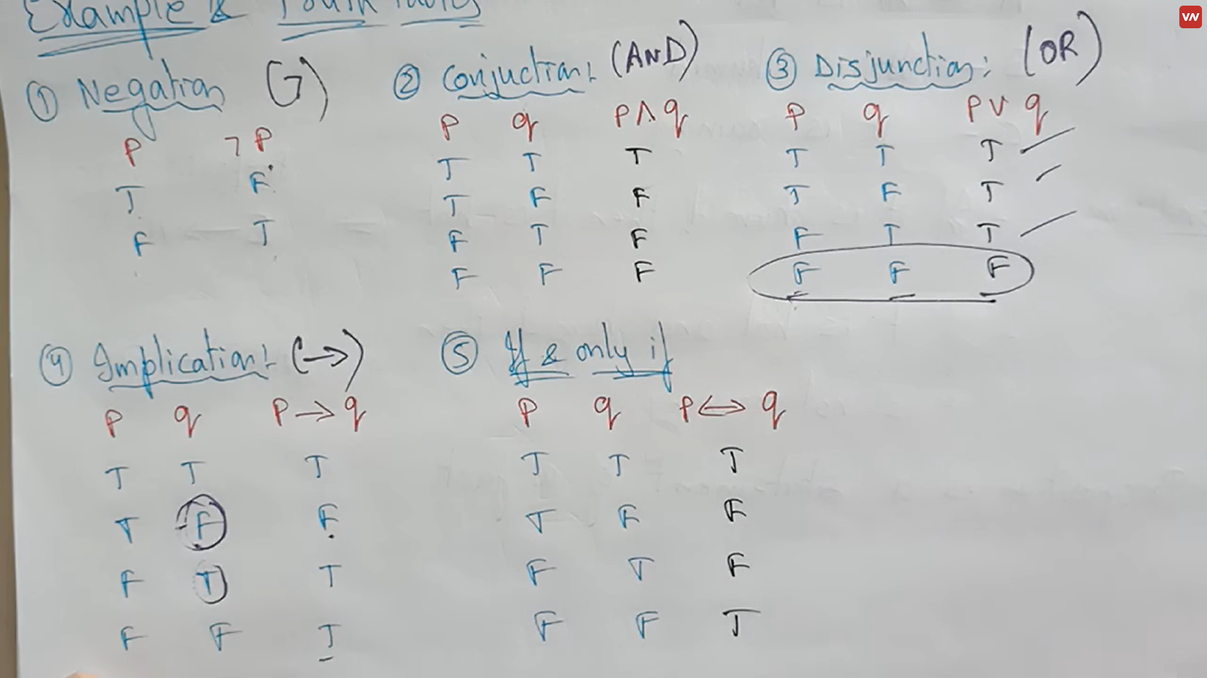

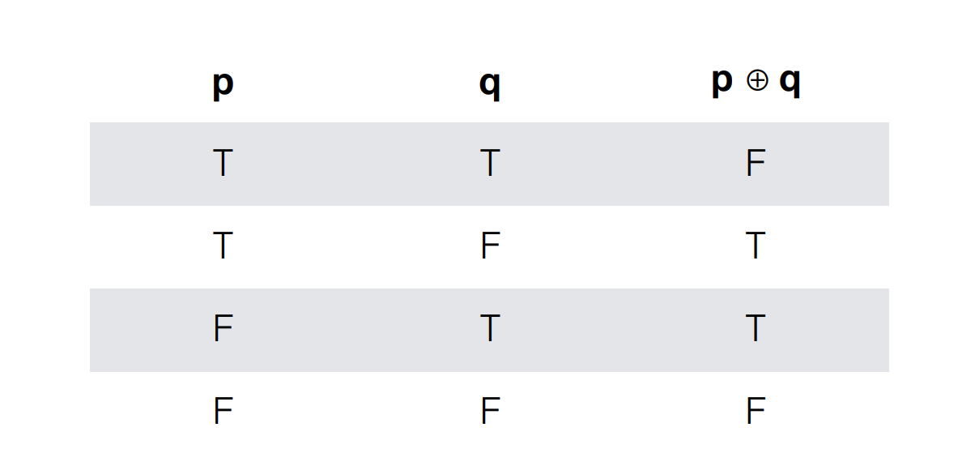

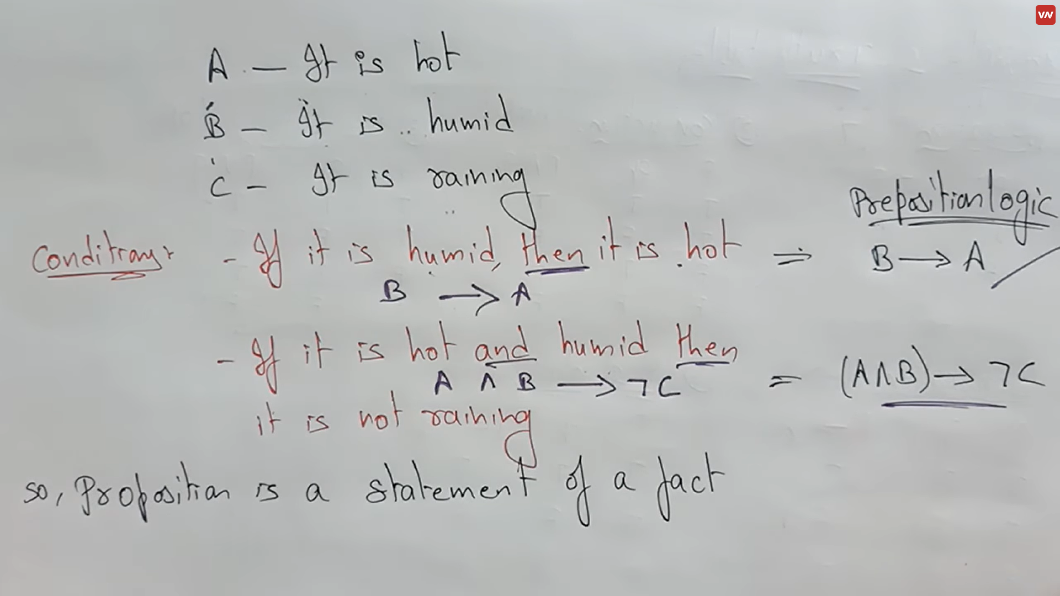

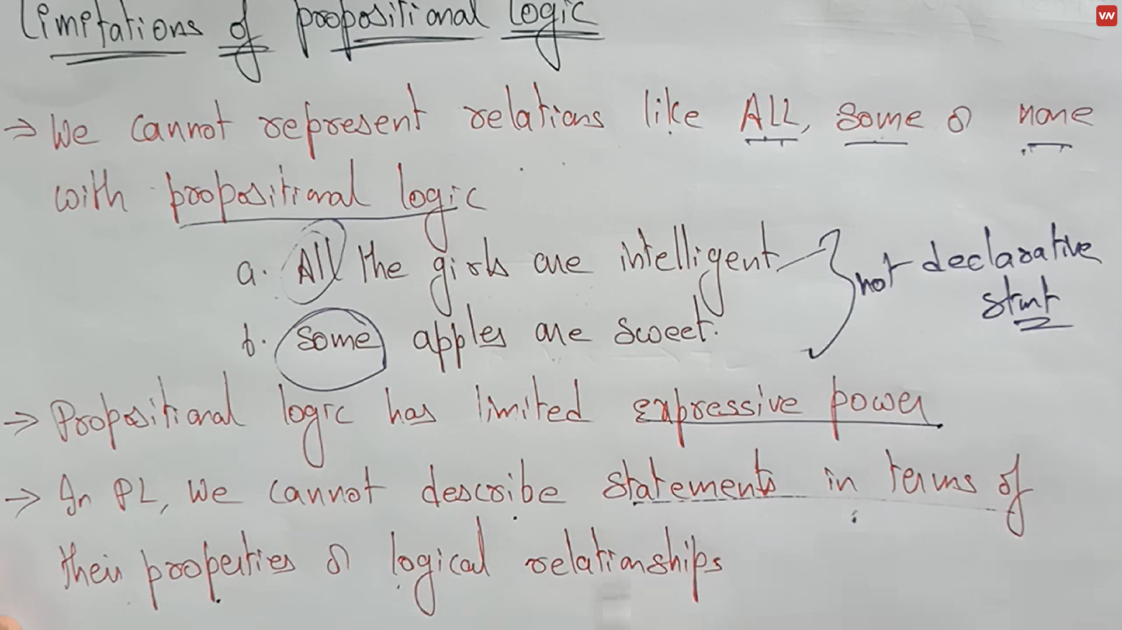

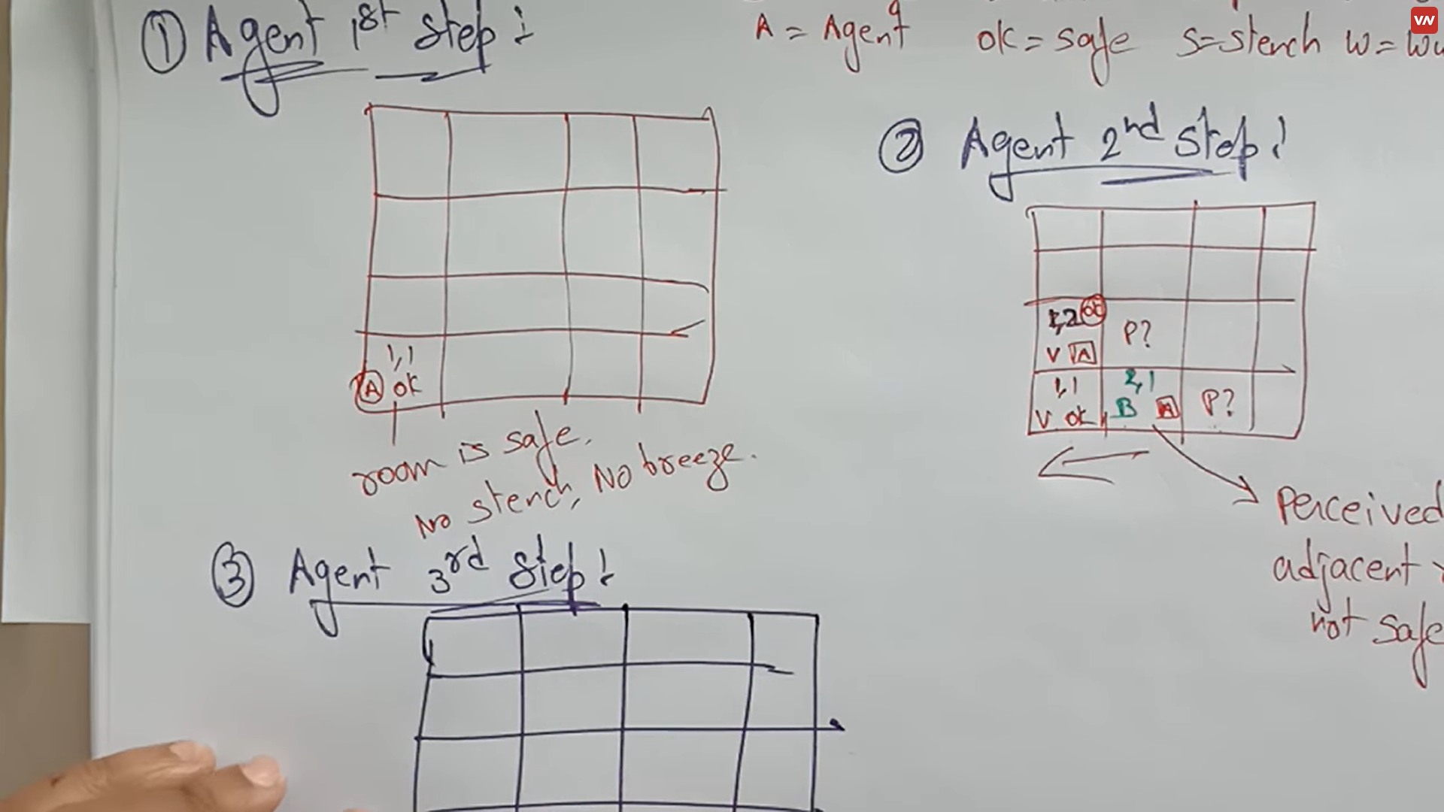

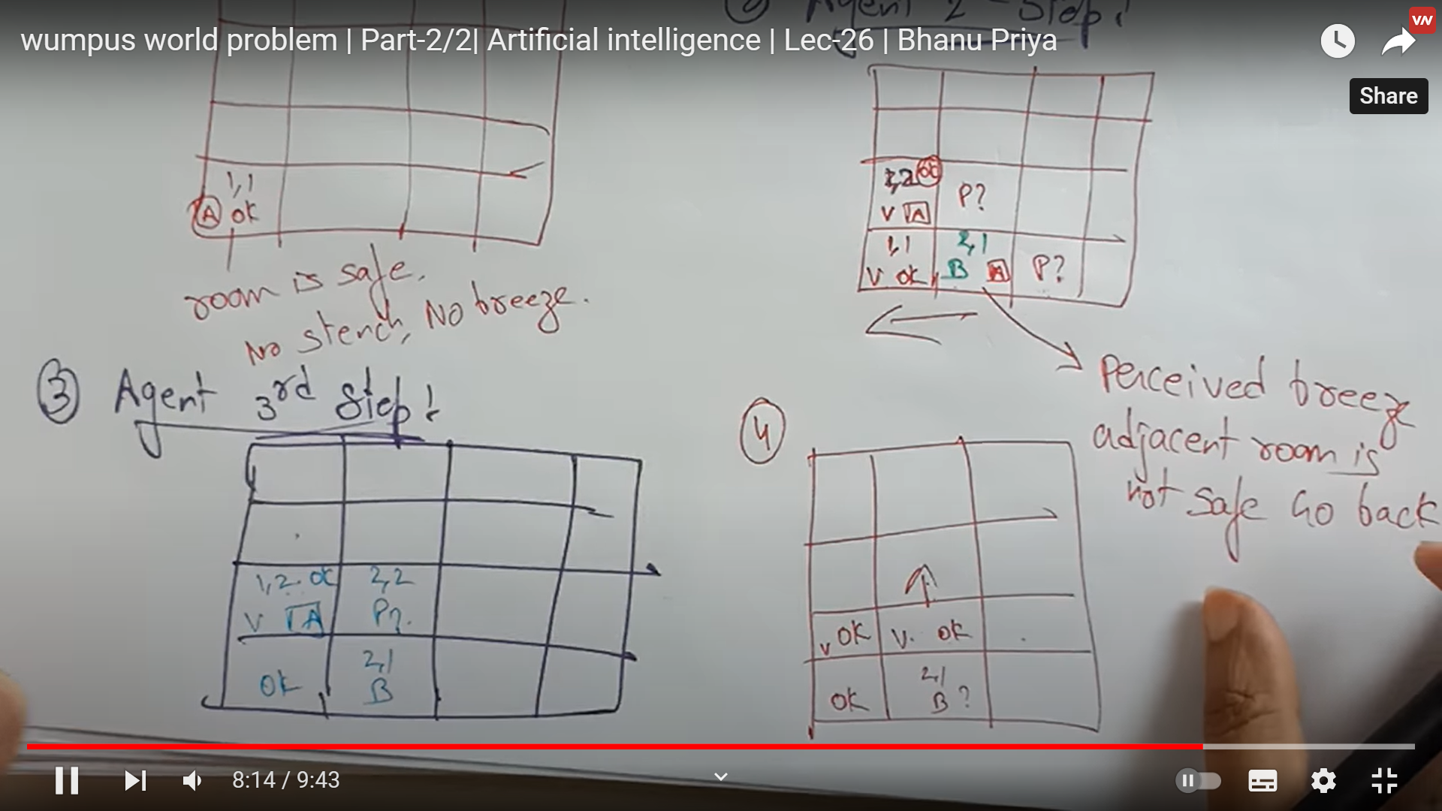

**FIRST ORDER LOGIC**

* First-order logic is another way of knowledge representation in artificial intelligence. It is an extension to propositional logic.
* FOL is sufficiently expressive to represent the natural language statements in a concise way.
* First-order logic is also known as **Predicate logic or First-order predicate logic**. First-order logic is a powerful language that develops information about the objects in a more easy way and can also express the relationship between those objects.
* First-order logic (like natural language) does not only assume that the world contains facts like propositional logic but also assumes the following things in the world:
  + **Objects:** A, B, people, numbers, colors, wars, theories, squares, pits, wumpus, ......
  + **Relations:** **It can be unary relation such as:** red, round, is adjacent, **or n-any relation such as:** the sister of, brother of, has color, comes between
  + **Function:** Father of, best friend, third inning of, end of, ......
* As a natural language, first-order logic also has two main parts:
  1. **Syntax**
  2. **Semantics**

## **Syntax of First-Order logic:**

The syntax of FOL determines which collection of symbols is a logical expression in first-order logic. The basic syntactic elements of first-order logic are symbols. We write statements in short-hand notation in FOL.

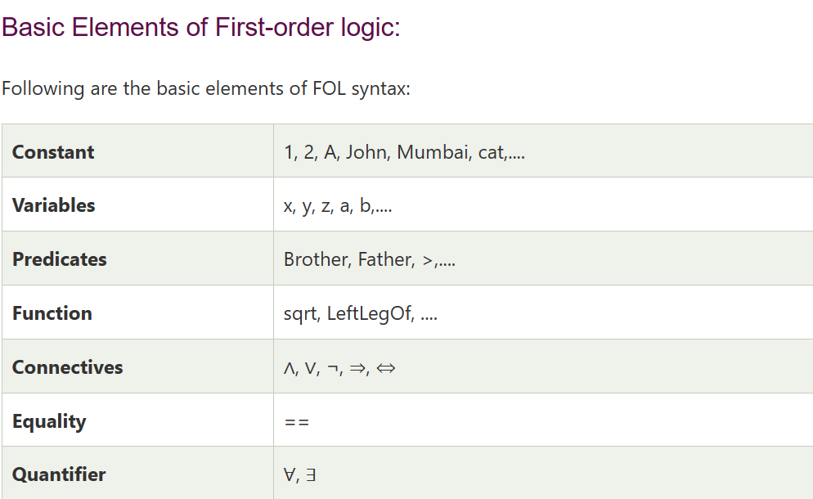

Atomic sentences:

* Atomic sentences are the most basic sentences of first-order logic. These sentences are formed from a predicate symbol followed by a parenthesis with a sequence of terms.
* We can represent atomic sentences as **Predicate (term1, term2, ......, term n)**.

Example: Ravi and Ajay are brothers: => Brothers(Ravi, Ajay).

Chinky is a cat: => cat (Chinky).

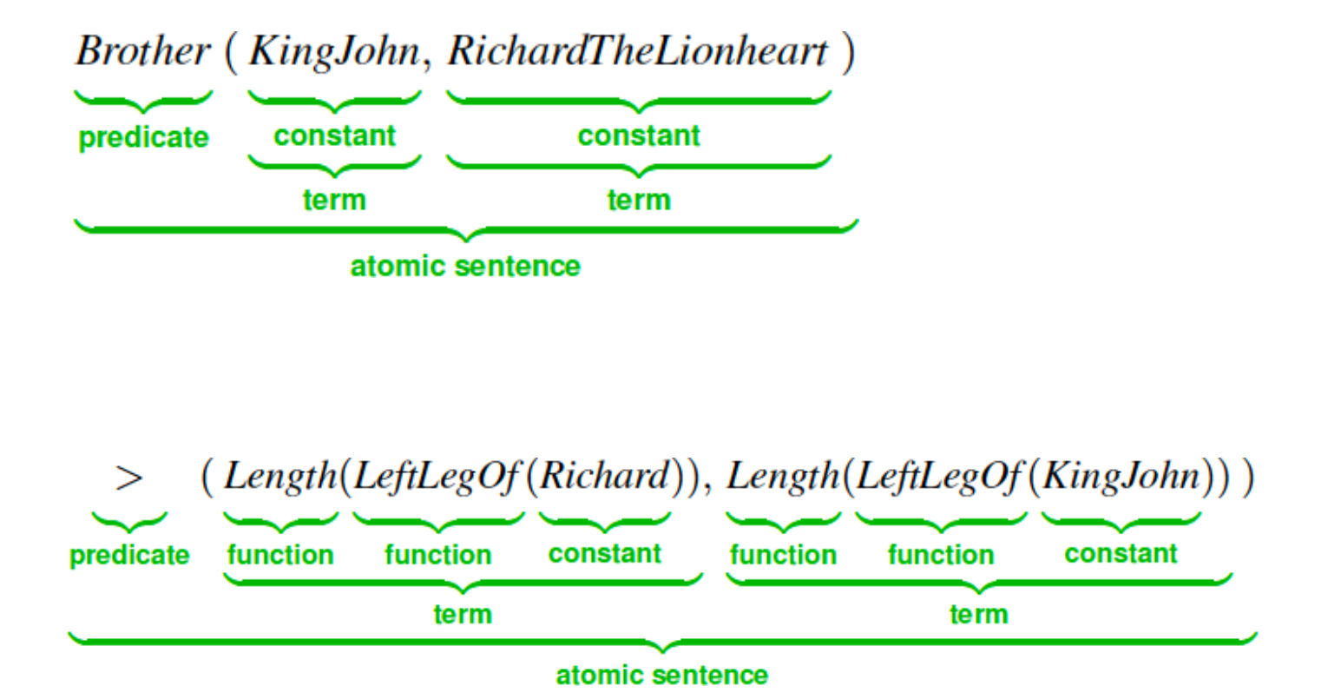

Complex Sentences:

* Complex sentences are made by combining atomic sentences using connectives.

**First-order logic statements can be divided into two parts:**

* **Subject:** Subject is the main part of the statement.
* **Predicate:** A predicate can be defined as a relation, which binds two atoms together in a statement.

**Consider the statement: "x is an integer."**, it consists of two parts, the first part x is the subject of the statement and second part "is an integer," is known as a predicate.

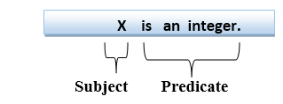

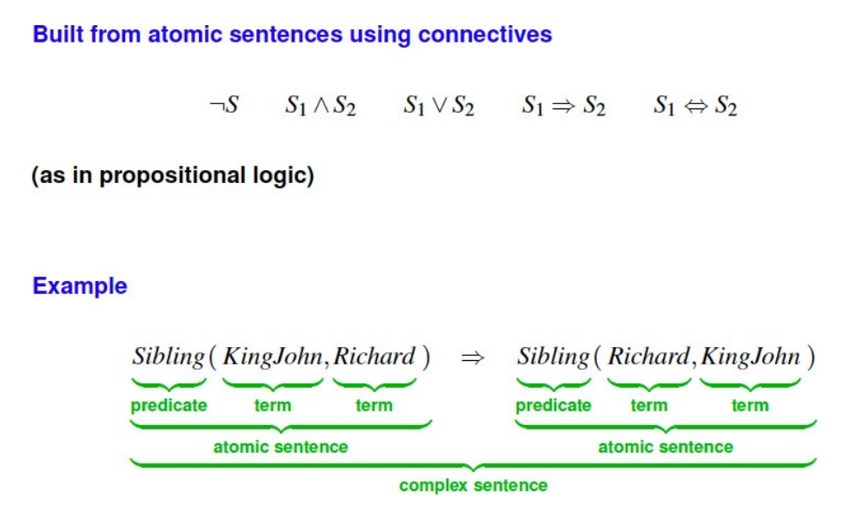

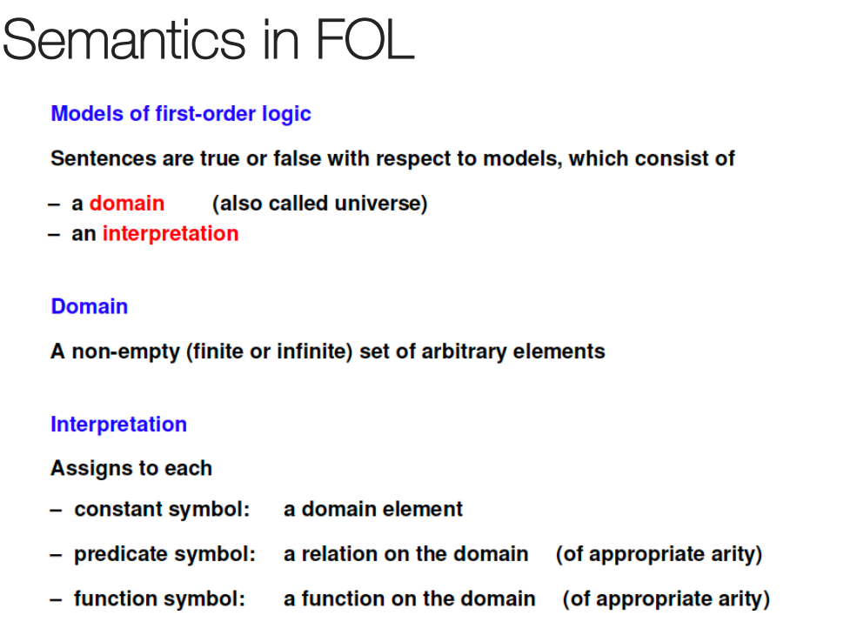

Quantifiers in First-order logic:

* A quantifier is a language element which generates quantification, and quantification specifies the quantity of specimen in the universe of discourse.
* These are the symbols that permit to determine or identify the range and scope of the variable in the logical expression. There are two types of quantifier:
  1. **Universal Quantifier, (for all, everyone, everything)**
  2. **Existential quantifier, (for some, at least one).**

### Universal Quantifier:

Universal quantifier is a symbol of logical representation, which specifies that the statement within its range is true for everything or every instance of a particular thing.

The Universal quantifier is represented by a symbol ∀, which resembles an inverted A.

If x is a variable, then ∀x is read as:

* **For all x**
* **For each x**
* **For every x.**

Note: In universal quantifier we use implication "→".

### Example:

**All man drink coffee.**

Let a variable x which refers to a cat so all x can be represented in UOD as below:

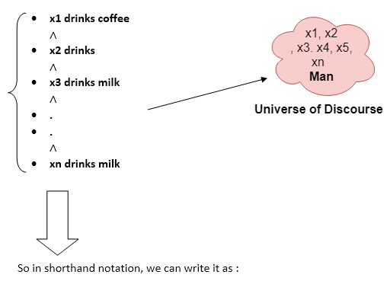

**∀x man(x) → drink (x, coffee).**

It will be read as: There are all x where x is a man who drink coffee.

Existential Quantifier:

Existential quantifiers are the type of quantifiers, which express that the statement within its scope is true for at least one instance of something.

It is denoted by the logical operator ∃, which resembles as inverted E. When it is used with a predicate variable then it is called as an existential quantifier.

Note: In Existential quantifier we always use AND or Conjunction symbol (∧).

If x is a variable, then existential quantifier will be ∃x or ∃(x). And it will be read as:

* **There exists a 'x.'**
* **For some 'x.'**
* **For at least one 'x.'**

Example:

**Some boys are intelligent.**

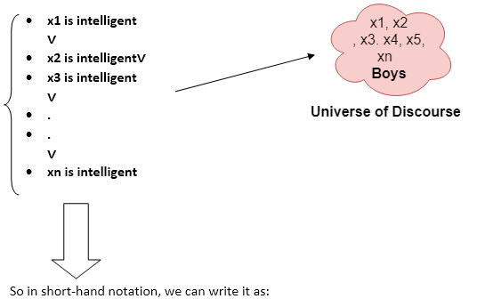

**∃x: boys(x) ∧ intelligent(x)**

It will be read as: There are some x where x is a boy who is intelligent.

Properties of Quantifiers:

In universal quantifier, ∀x∀y is similar to ∀y∀x.

In Existential quantifier, ∃x∃y is similar to ∃y∃x.

∃x∀y is not similar to ∀y∃x.

Some Examples of FOL using quantifier:

1. All birds fly.

In this question the predicate is "fly(bird)."

And since there are all birds who fly so it will be represented as follows.

∀x bird(x) →fly(x).

2. Every man respects his parent.

In this question, the predicate is "respect(x, y)," where x=man, and y= parent.

Since there is every man so will use ∀, and it will be represented as follows:

∀x man(x) → respects (x, parent).

3. Some boys play cricket.

In this question, the predicate is "play(x, y)," where x= boys, and y= game. Since there are some boys so we will use ∃, and it will be represented as:

∃x boys(x) → play(x, cricket).

4. Not all students like both Mathematics and Science.

In this question, the predicate is "like(x, y)," where x= student, and y= subject.

Since there are not all students, so we will use ∀ with negation, so following representation for this:

¬∀ (x) [ student(x) → like(x, Mathematics) ∧ like(x, Science)].

5. Only one student failed in Mathematics.

In this question, the predicate is "failed(x, y)," where x= student, and y= subject.

Since there is only one student who failed in Mathematics, so we will use following representation for this:

∃(x) [ student(x) → failed (x, Mathematics) ∧∀ (y) [¬(x==y) ∧ student(y) → ¬failed (x, Mathematics)].